**Capstone Design**

**Manual**



Subject: Capstone Design Project

Professor: Yeongbin, KWON

Team name: KKW

Members: Minjo, KIM 20131961

Yeongseo, KOO 20130398

Jeonghyun, WOO 20134220

Materials : NFC sticker, Smartphones with NFC function, Findme application

NFC sticker(White = NTAG216, Blude = NTAG213, you can use all kinds of stickers)

1. Download findme application (app-debug.apk in source folder) or you can build apk in android studio based on the source code.
2. Set NFC mode as the default mode(기본 모드) in the smartphone settings and run the app.

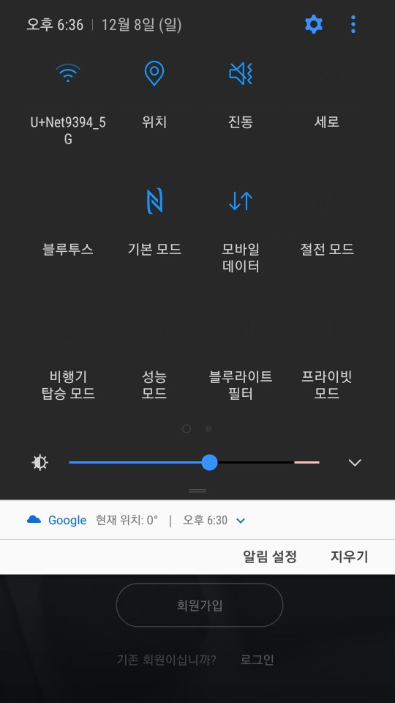

1. On the sign up page, press the “회원가입” button and proceed sign up.

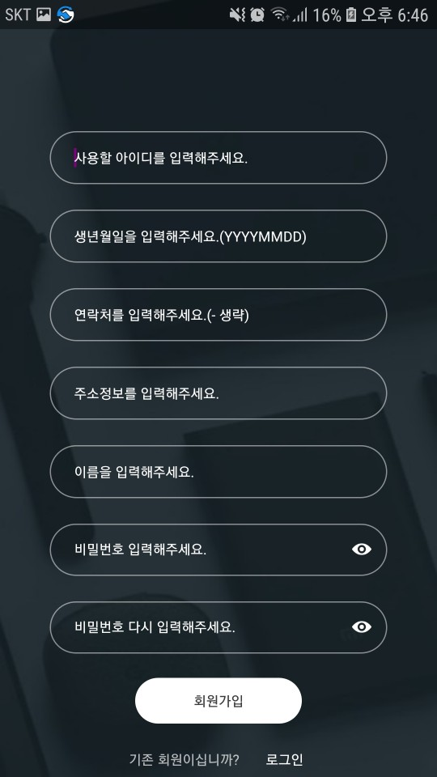

1. After finishing sign up, press the “로그인” button and proceed sign in.

1. When you are logged in, you will see your home. Our app doesn’t have a home button, so if you slide the left screen to the middle, you get a sidebar menu.

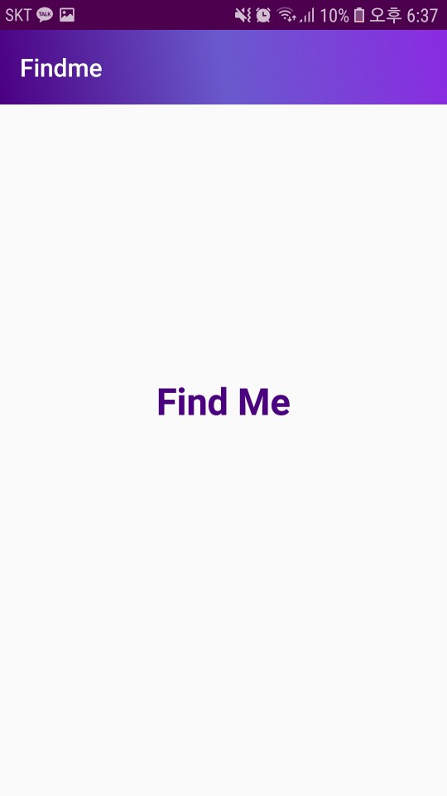

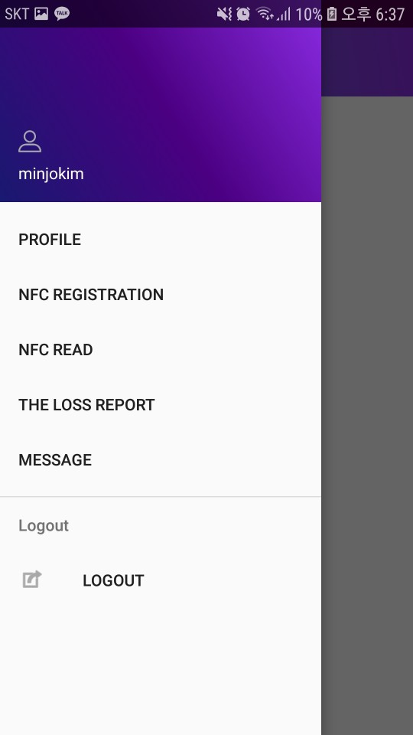

1. If you press NFC registration on the sidebar menu to go to the NFC registration screen.
2. If you click the “ADD ITEM” button on the NFC registration screen, a popup window for registering an item appears. And then, write the name of the item, register a new password to register NFC information and then choose the photo. When this is done, press the register button. The item is then registered.

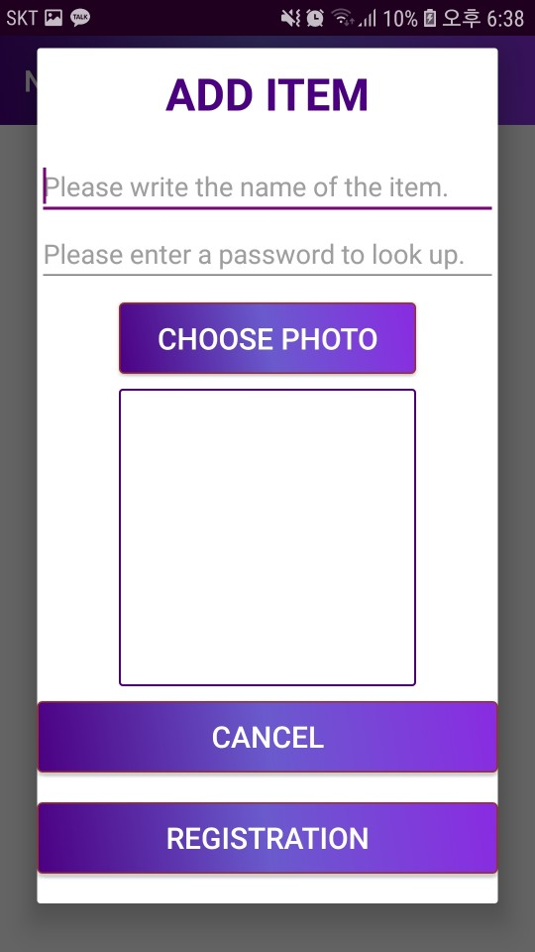

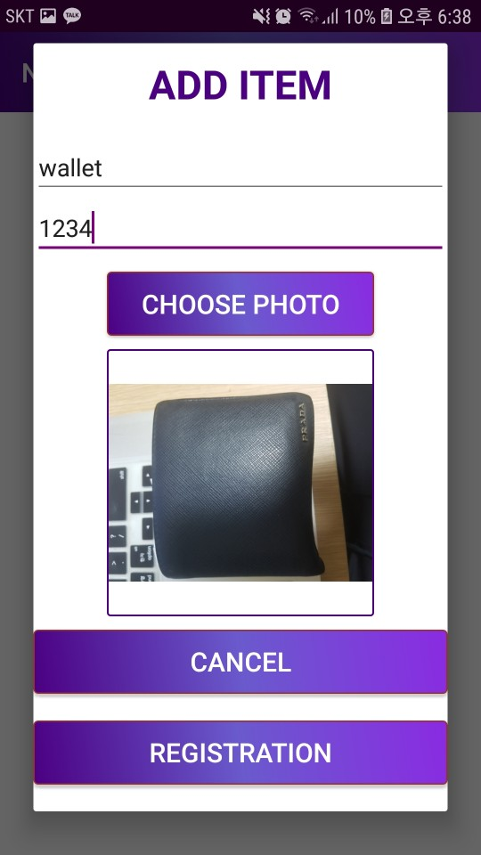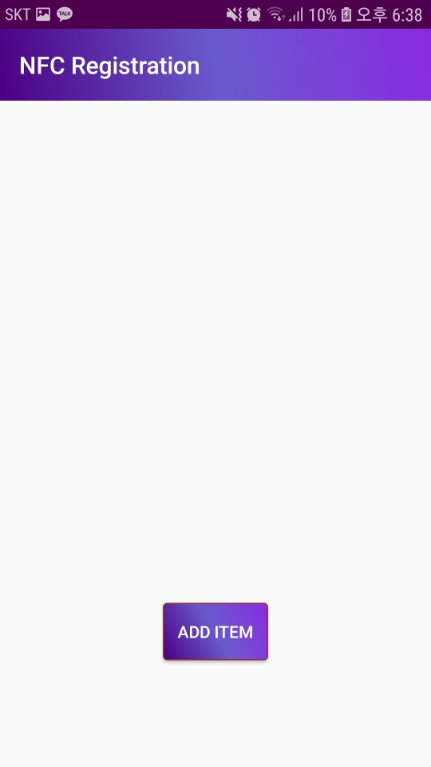

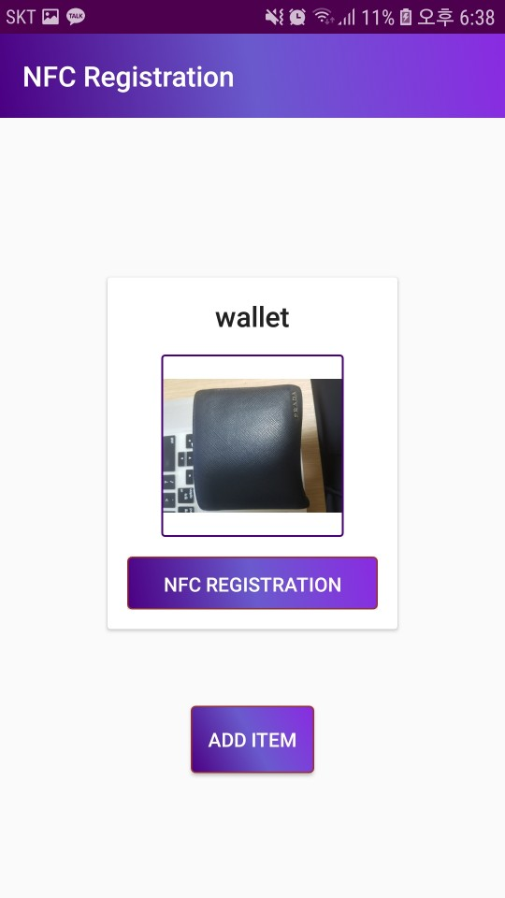

1. Place the NFC sticker on the back of the phone and press the NFC registration button to register the information on the NFC sticker. When registering here, you need to enter your password to register. (It sets a password to prevent others form overwriting other information on NFC stickers.). When the toast alarm(Text written to the NFC tag successfully!), registration is complete.

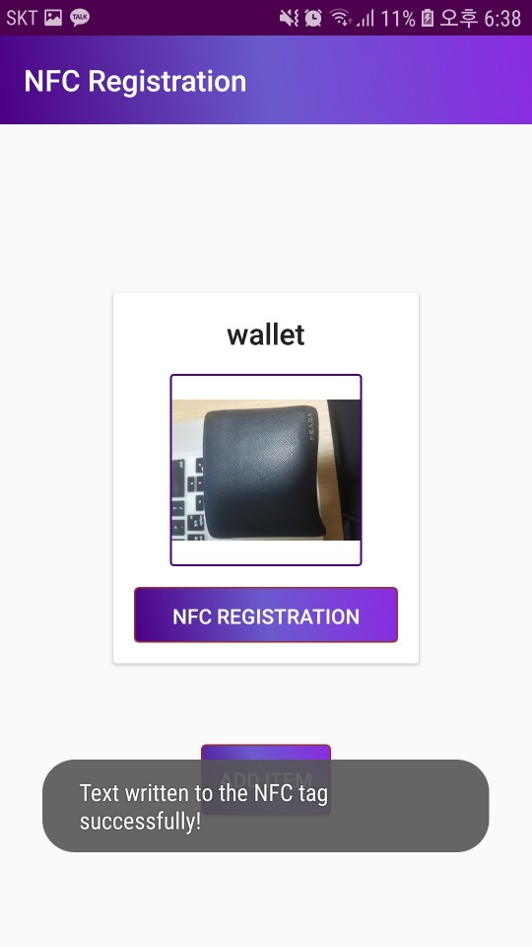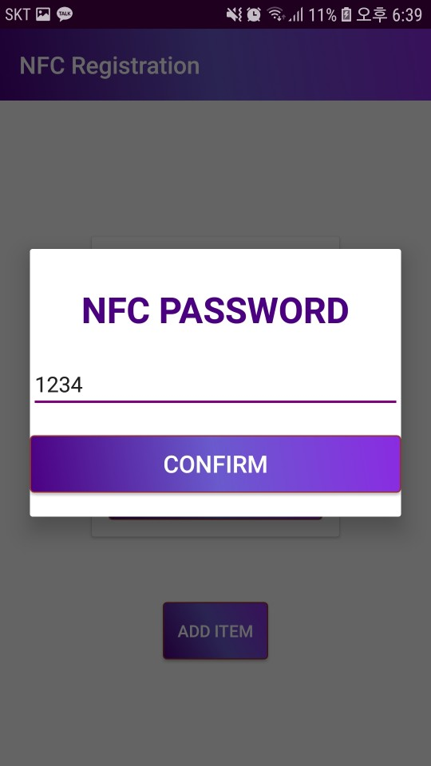

1. After registration, slide the left side again to turn on the side menu, and then click the NFC read menu.

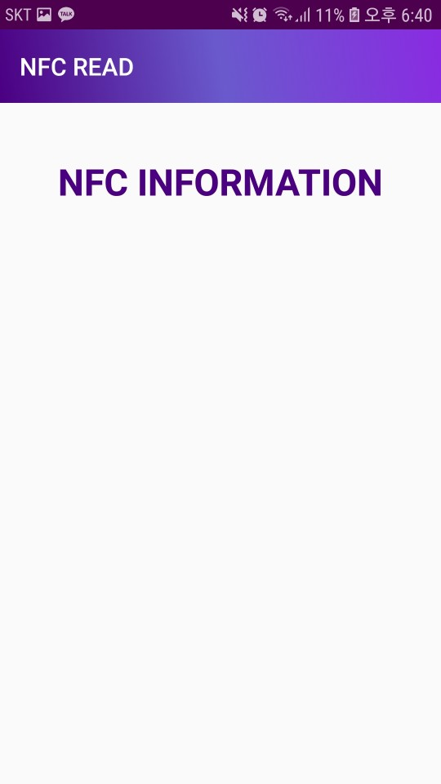

1. On the NFC read screen, place an NFC sticker on the back of your smartphone to see the information. Information will appear and an alert button will appear. Pressing the alert button will alert the owner of the NFC sticker and send a message directly. This message allows the user to find things directly from the owner. (If the owner is himself, the alarm goes to himself.)

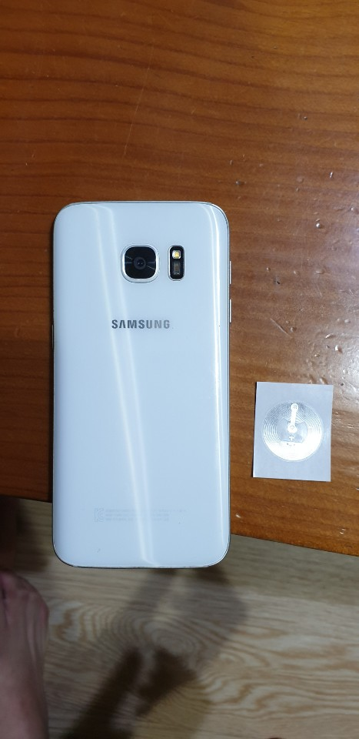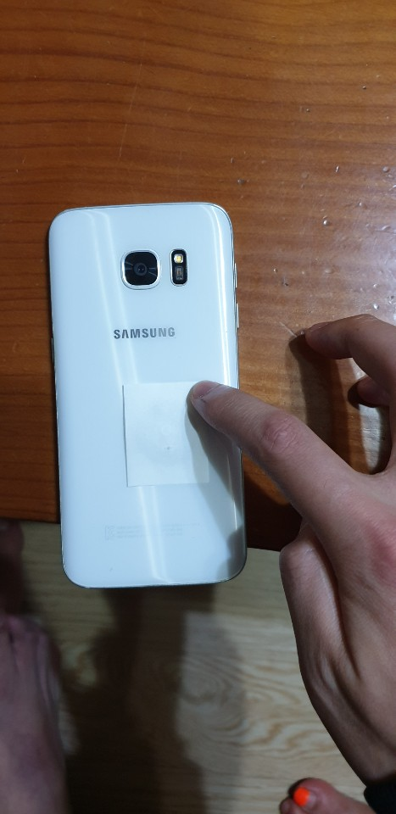

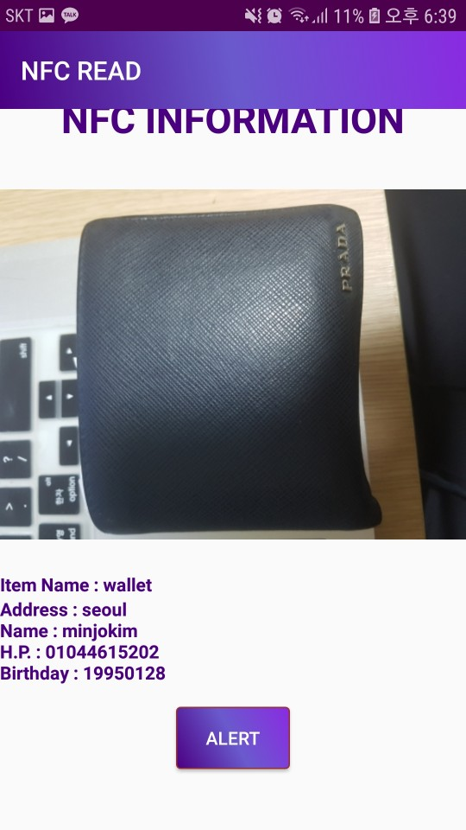

1. If the user clicks lost report in the side menu again and clicks the select from inventory button in the lost report screen, the user can select from among the registered items. If you select the item and press the submit button, the 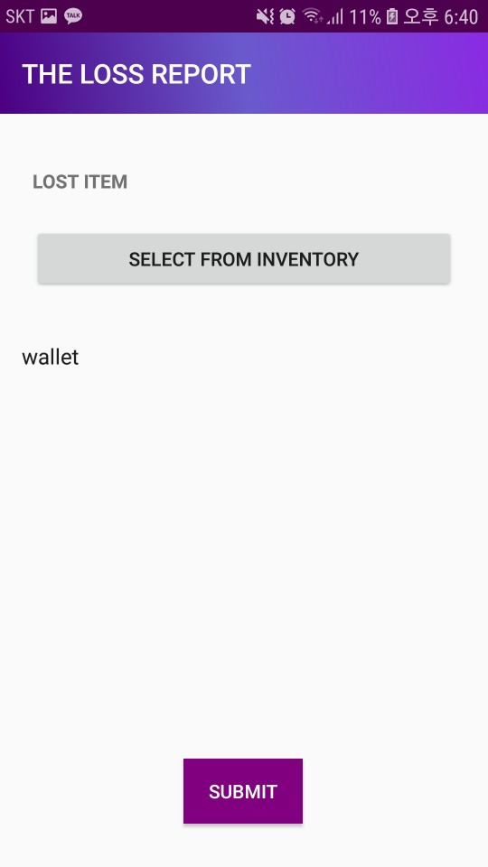information will be sent to the lost & found center (administrator).

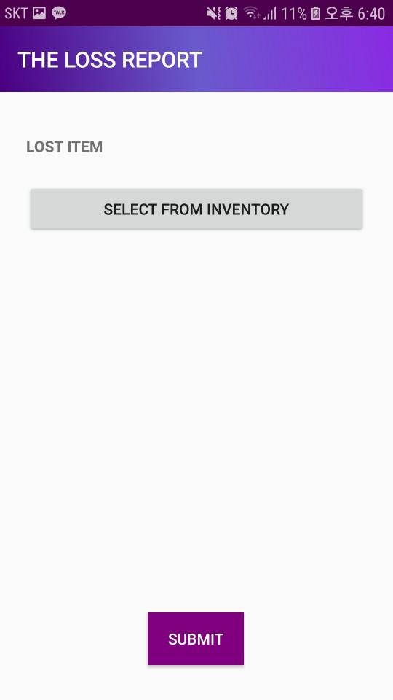

1. When you go to the profile screen from the side menu, you can go to the profile screen, where you can navigate and log out of the menu.

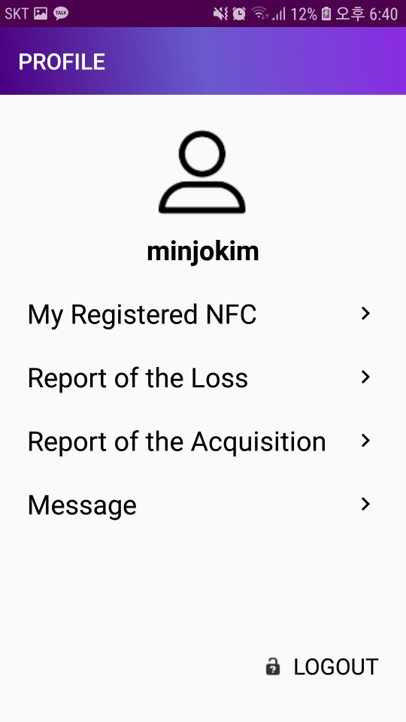

1. To log in as an administrator, log in with ID = admin password = 1234 on the login screen.

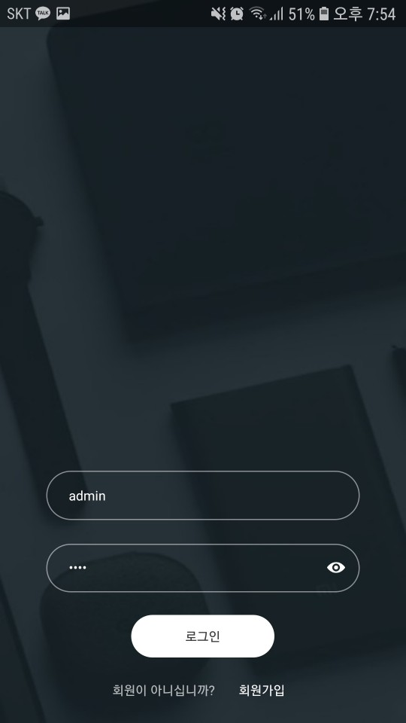

1. Similarly, pressing acquisition report from the side menu will display a list of lost reports registered by users. From there, select the item and press the alert button to send an alarm and message to that user. When a message room is created, you can send messages to that user. (There is only a loss report in the user interface and an acquisition report in the administrator interface.)

